<http://newindianexpress.com/cities/bangalore/Samaja-Seva-Samithi-A-12-year-old-tradition-of-selfless-service/2013/08/06/article1719841.ece>

# Samaja Seva Samithi: A 12-year-old tradition of selfless service

By Chetana Divya Vasudev - BANGALORE

06th August 2013 07:39 AM

* [Photos](http://newindianexpress.com/cities/bangalore/Samaja-Seva-Samithi-A-12-year-old-tradition-of-selfless-service/2013/08/06/article1719841.ece#tabs-275876-1)
* 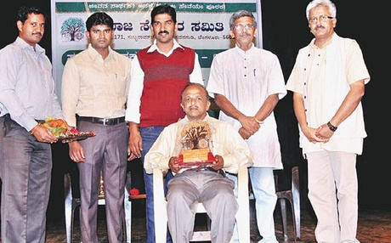

M R Anantha Kumar being honoured by Samaja Seva Samithi.

There's a day dedicated to people from every walk of life, Mother's day, Father's day, Teacher's day, Doctor's day and so on. But what about those who perform selfless service, asks Raghavendra B Agarkhed, treasurer, Samaja Seva Samithi. "That's why we celebrate August 1 as 'Samaja Sevakara Dinacharane'," he says, referring to their 12-year-old tradition of celebrating this event. This year, the organisation honoured M R Ananth Kumar, founder of Kaliyuva Mane, Mysore and Neelkanth Murthy, Odekar Farm, Tumkur.

In 2001, 15 mechanical engineering graduates sitting at Ramanjaneya gudda, Hanumanthanagar, read an article on the pathetic life of an artiste in a Kannada daily. The piece described the hardships of Ramachandra Jalihala, a musician from Chittapur, Gulbarga district, who taught music to interested people free of cost. The friends were amazed at the apathy of the society towards such a veteran  and decided to lend a helping hand.

Unemployed, they wondered what they could do. That was how Samaja Seva Samithi with an aim to bring recognition to those who perform selfless service was born. "Initially, we decided to send money to him, but a lot of people rebuked us, saying 'You're jobless. How will you help other people?'," said Rajkumar N, secretary, Samaja Seva Samithi. However, the Samithi pulled off the first edition of the annual Social Workers' day celebration in August 2002 and there has been no looking back since.

In 2006, at the insistence of Raghavendra's friend Anjan, Samaja Seva Samithi got 15 t-shirts printed with verses from D V Gundappa's Manku Timmana Kagga and G P Rajaratnam's Narakakk Ilsi, Nalge Silsi and other literary works.

What was meant to be an experiment, became popular over a period of time. "People would stop us on the road, in bus stops, asking us where we bought them. Gradually, we started receiving orders for t-shirts," says Rajkumar.

Enthused by the success of the t-shirts, the organisation moved on to printing greeting cards on similar lines. "We put up stalls at various cultural and literary events and here too, they were in great demand. We wanted to revive the culture of sending wishes and greetings by post rather than emailing them."

Apart from this, the Samithi is providing old newspapers to Abalashrama, a home for destitute girls in Basavanagudi for making paper bags. The members also began marketing these eco-friendly bags and landed Abalashrama their first ever order from an ethnic clothes store.

"The money earned from this activity is transferred to the girls' accounts and becomes savings that they can use after marriage. Now, anyone who wants bags from them has to place an order two months in advance," says Gangadhara B Y, a founder member of Samaja Seva Samithi.